PCR Application
———
Administrator Guide

Volunteer Crisis Response Team
University of Ottawa

Version 1.0 — August 2026
This guide covers report review, user management, and system administration for PCR application administrators. For the day-to-day report-writing workflow, see the separate User Guide — administrators can do everything a regular user can do, plus everything in this guide.

Contents
1. Introduction
2. Logging In
3. The Administrator Dashboard
4. The Report Review Workflow
5. Reviewing Submitted Reports
6. Viewing a Report's PDF
7. Approving a Report
8. Requesting Changes Instead of Approving
9. Editing Any Report Directly
10. Deleting Reports
11. Managing Users
Creating a User
Editing a User
Resetting a Password
Activating and Deactivating a User
12. Managing the Responder List
13. Semester Setup and Roster Review
Start of Semester
Winter Semester Review
14. Activity Logs
15. Quick Reference

1. Introduction
Administrators are responsible for reviewing every Patient Care Report submitted through the application, keeping the responder and user list current, and monitoring system activity. An administrator account can do everything a regular user account can — fill out and submit PCRs — plus everything covered in this guide.
This guide assumes you're already comfortable with the parts of the application that work the same way for everyone (logging in, the PCR form itself, drafts). Those are covered in full detail in the User Guide and aren't repeated here except where admin behaviour differs.
Note Screenshots in this guide were taken from a test copy of the application, so the names, dates, and report numbers you see won't match your real data. The layout and behaviour are the same.

2. Logging In
Sign in the same way any user does: enter your username and password on the login screen and click Sign In. The application recognizes your account as an administrator automatically and unlocks the extra screens and actions covered in this guide — there's no separate admin login.
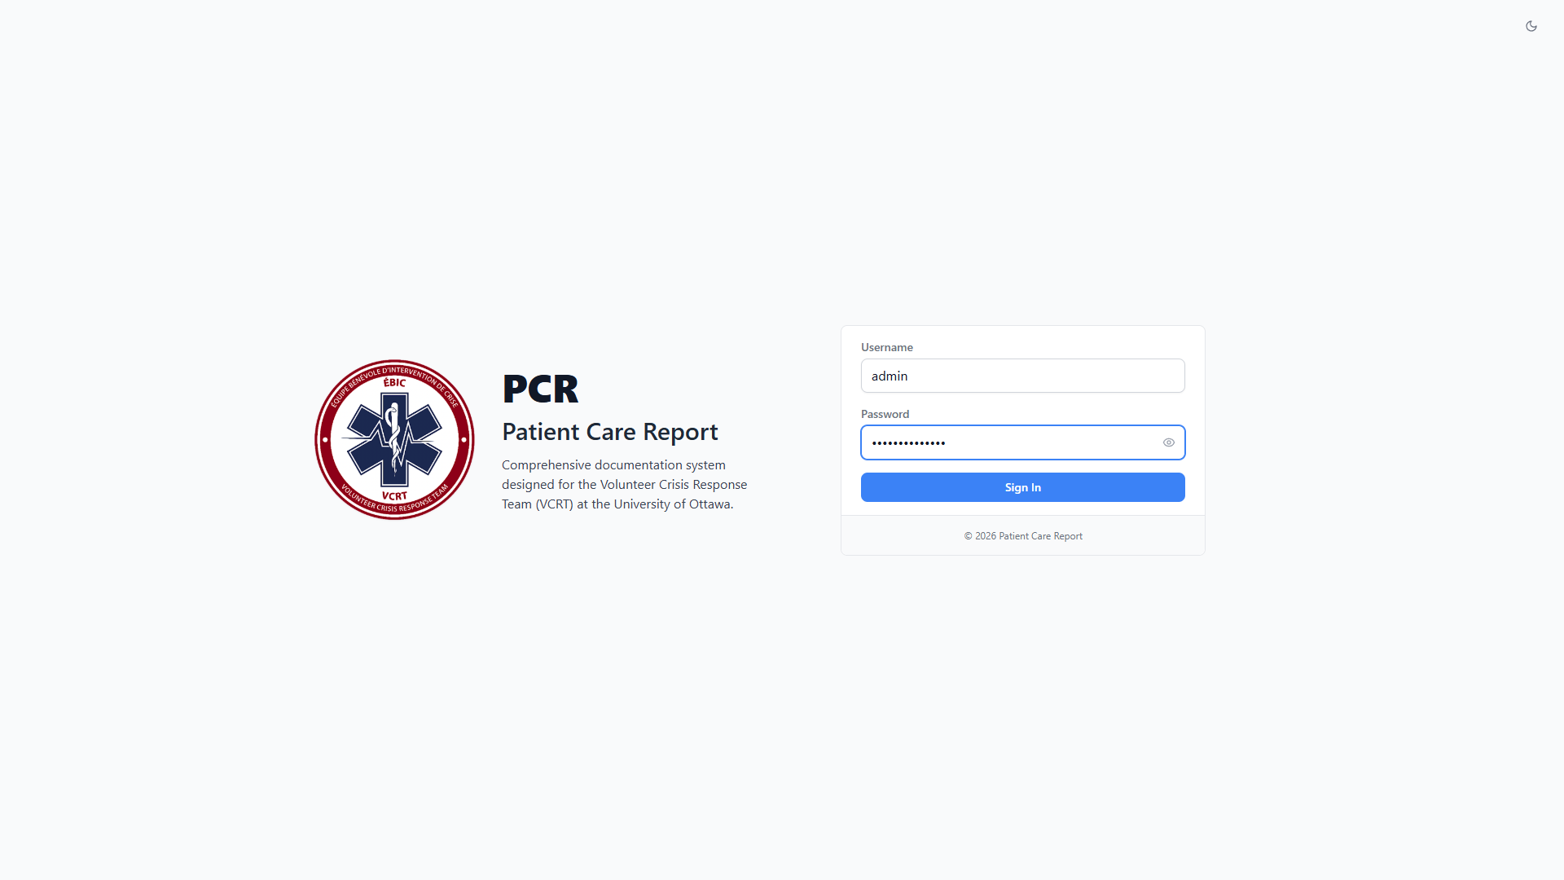
Figure 1. Signing in with an administrator account.

3. The Administrator Dashboard
The Dashboard looks and works the same as it does for a regular user, with two differences: the call statistics widget shows organization-wide totals instead of just your own calls, and you get an editable control for the supply-usage form link instead of a read-only view of it.
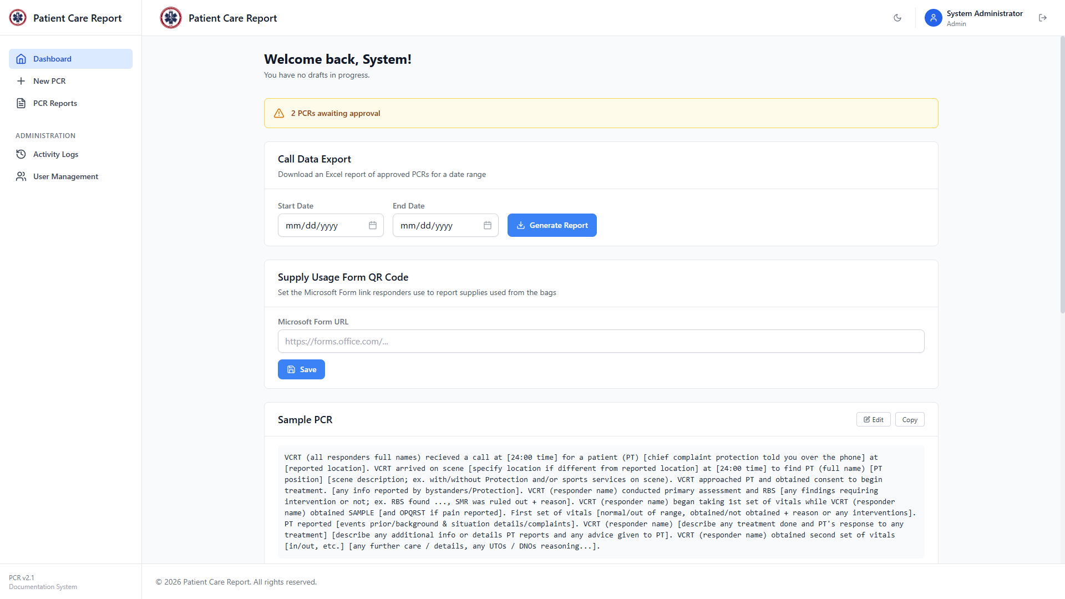
Figure 2. The Administrator Dashboard.

Figure 3. Further down the Administrator Dashboard: organization-wide call statistics and the supply-usage form link.
The supply-usage form is a link (shown to regular users as text or a QR code) that you can point at a Microsoft Form or other external form used to log supplies used on a call. Enter the URL and click Save to set or change it.

4. The Report Review Workflow
Every PCR is always in one of four states. As an administrator, you have visibility into all of them and control over the transitions between the last three.
Status | Who sees it | What you can do
Draft | Only its owner. | Nothing — drafts are private to the user until submitted.
Submitted | Its owner and all admins. | Approve it, send it back with Request Changes, edit it directly, view or delete it.
Changes Requested | Its owner and all admins. | View your own comments, edit it directly, or delete it. The owner can also edit and resubmit it.
Approved | All admins (the owner loses visibility). | View, edit, or delete it.

Note Once you approve a report, it disappears from the submitting user's PCR Reports list. This is intentional — approved reports are finalized records, and from that point on they're maintained by administrators rather than the original submitter. If a user asks about a report they can no longer see, that's why.

5. Reviewing Submitted Reports
Click PCR Reports in the sidebar. As an admin, this list shows every submitted, changes-requested, and approved report in the system — not just your own — along with a Created By column showing who submitted each one.
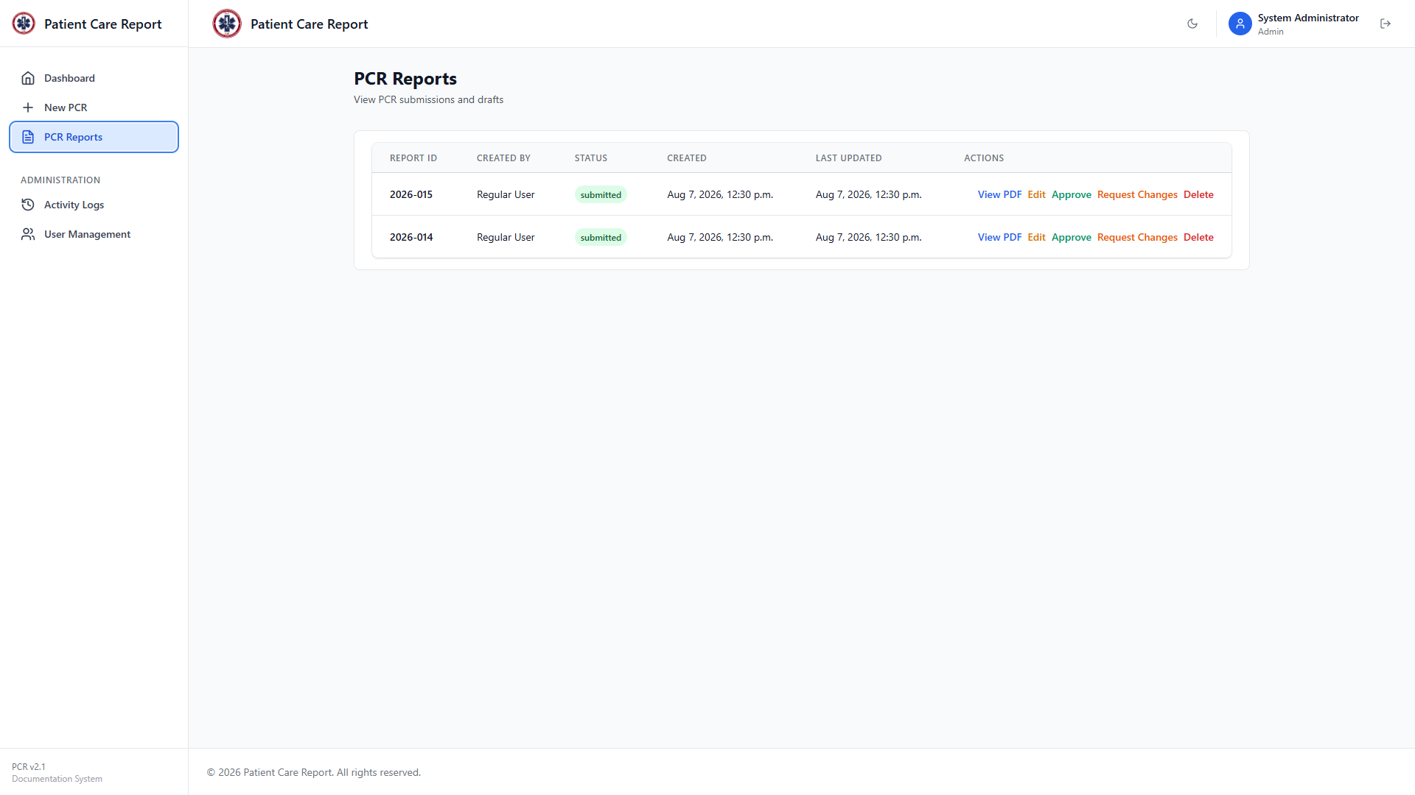
Figure 4. The PCR Reports list as seen by an administrator, with two reports awaiting review.
Each submitted report gives you five actions: View PDF, Edit, Approve, Request Changes, and Delete. The next few sections cover each of these.

6. Viewing a Report's PDF
Click View PDF on any row, or click the row itself, to open the generated report as a PDF.
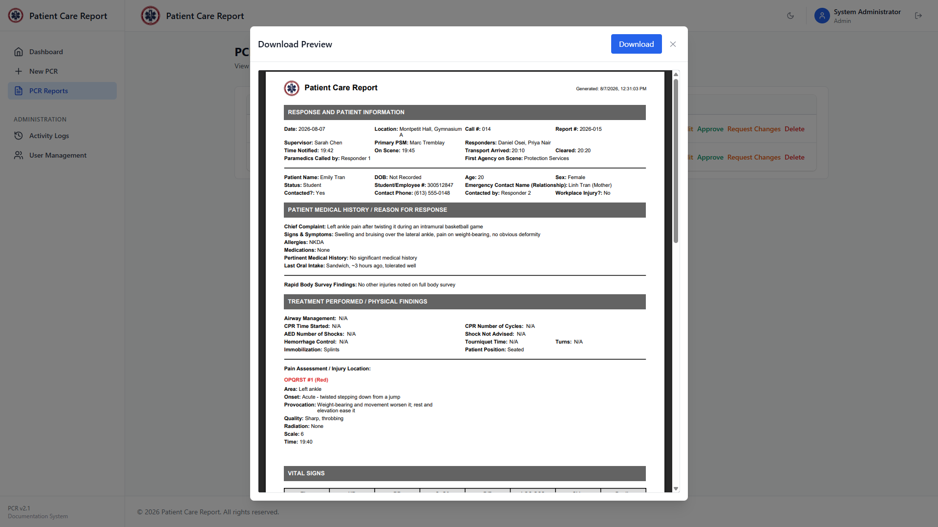
Figure 5. Viewing a report's PDF as an administrator. Unlike the view a regular user gets, this includes a Download button.
Unlike a regular user, you can click Download in this window to save a copy of the PDF to your own device.

7. Approving a Report
Once you've reviewed a submitted report and it's complete and accurate, click Approve on its row. There's no confirmation step — the status changes immediately.
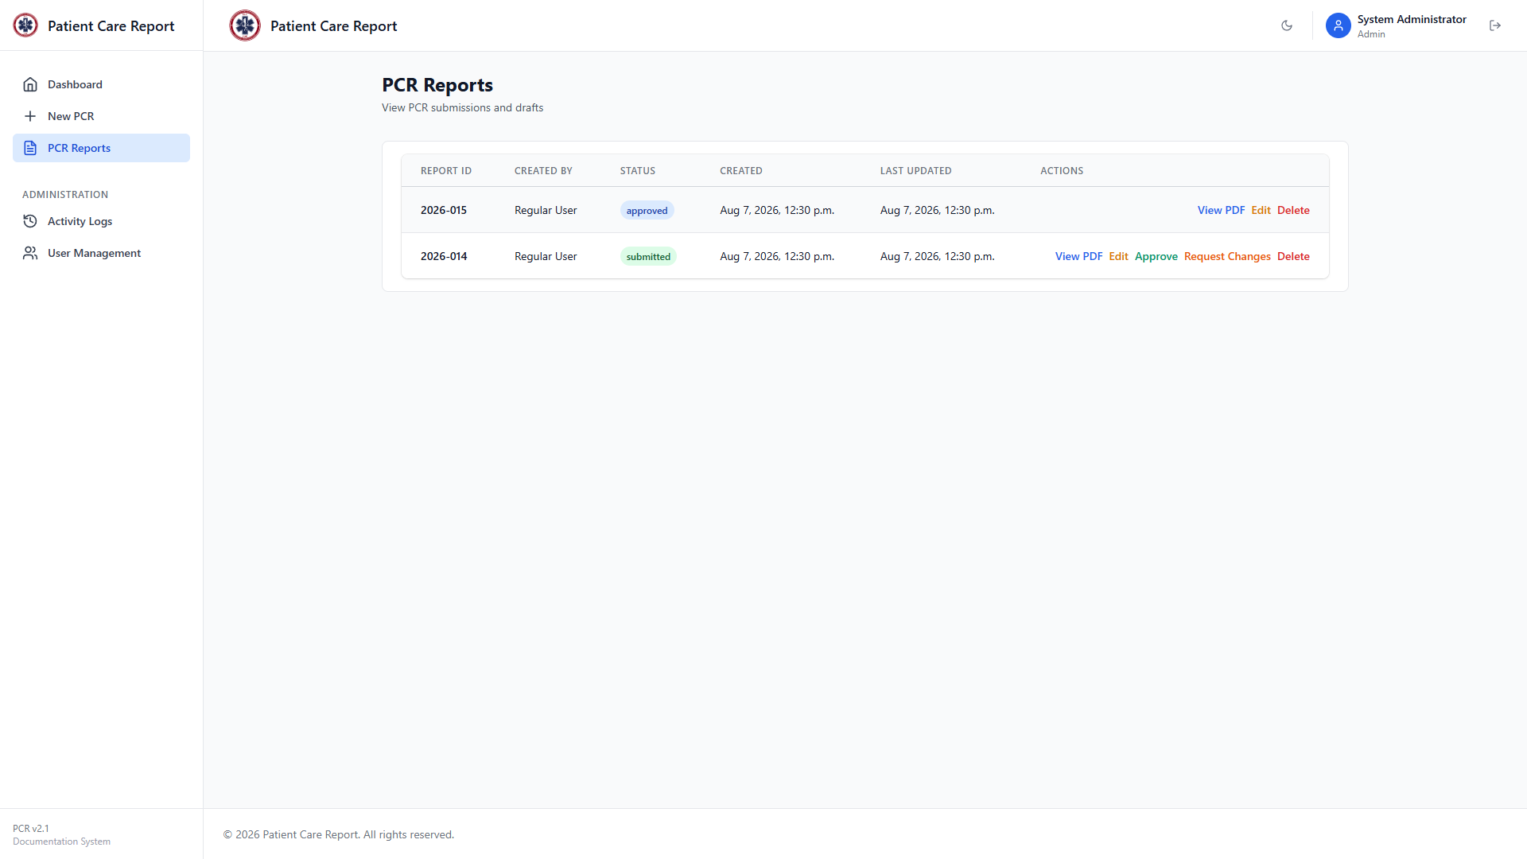
Figure 6. A report's status changes to approved immediately after clicking Approve.
Note Approving is final from the submitter's side: the report leaves their PCR Reports list and they can no longer edit it. Double-check the report before approving — if you spot a problem afterward, you can still edit it yourself (Section 9) or delete it, but the user can no longer fix it themselves.

8. Requesting Changes Instead of Approving
If a submitted report has a problem the submitter needs to fix — missing information, an inconsistency, a typo in something important — send it back to them instead of approving it or editing it yourself.
1. Click Request Changes on the report's row.
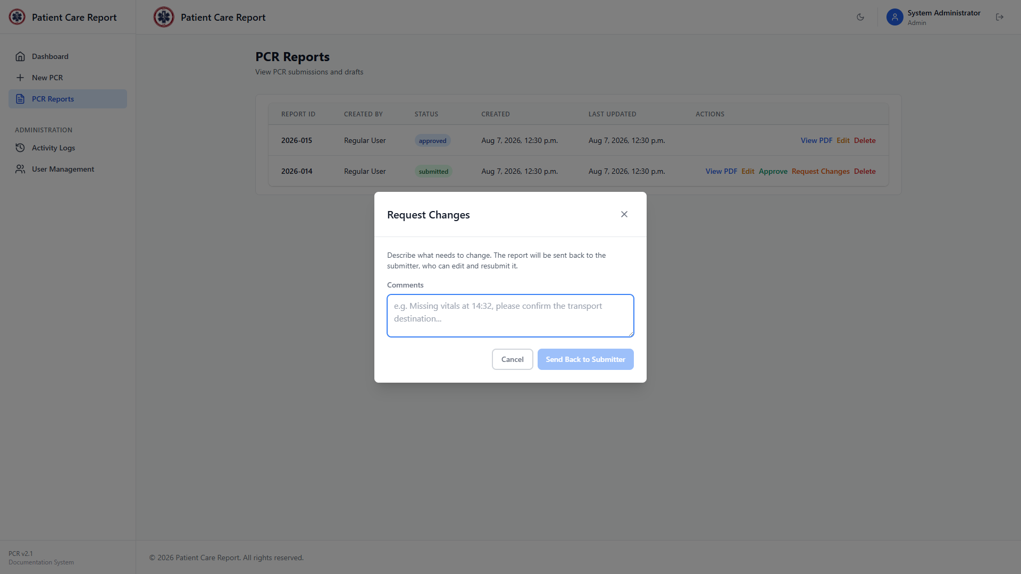
Figure 7. The Request Changes window.
2. Type a clear description of what needs to change. Be specific enough that the submitter doesn't have to guess — reference the exact field or section where possible.
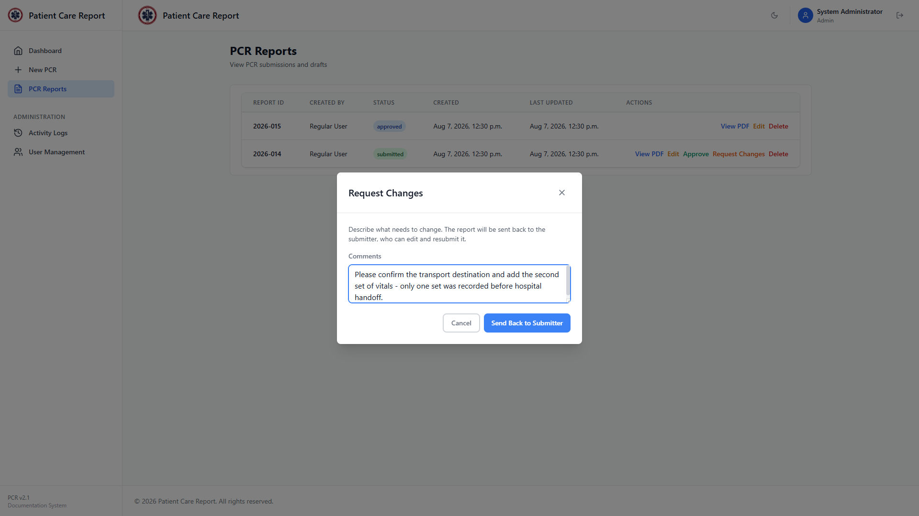
Figure 8. Comments describing what the submitter needs to fix.
3. Click Send Back to Submitter.
The report's status changes to Changes Requested, and your comment is attached to it. The row shows a View comments link so you (or anyone else reviewing the report) can see what was asked for.
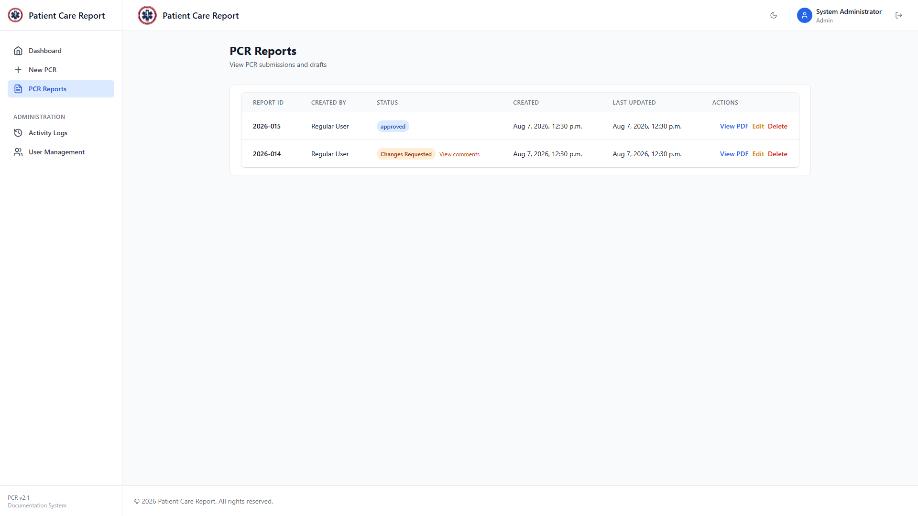
Figure 9. The report's status after sending it back for changes, with a View comments link.
4. Click View comments at any time to review what was asked for.
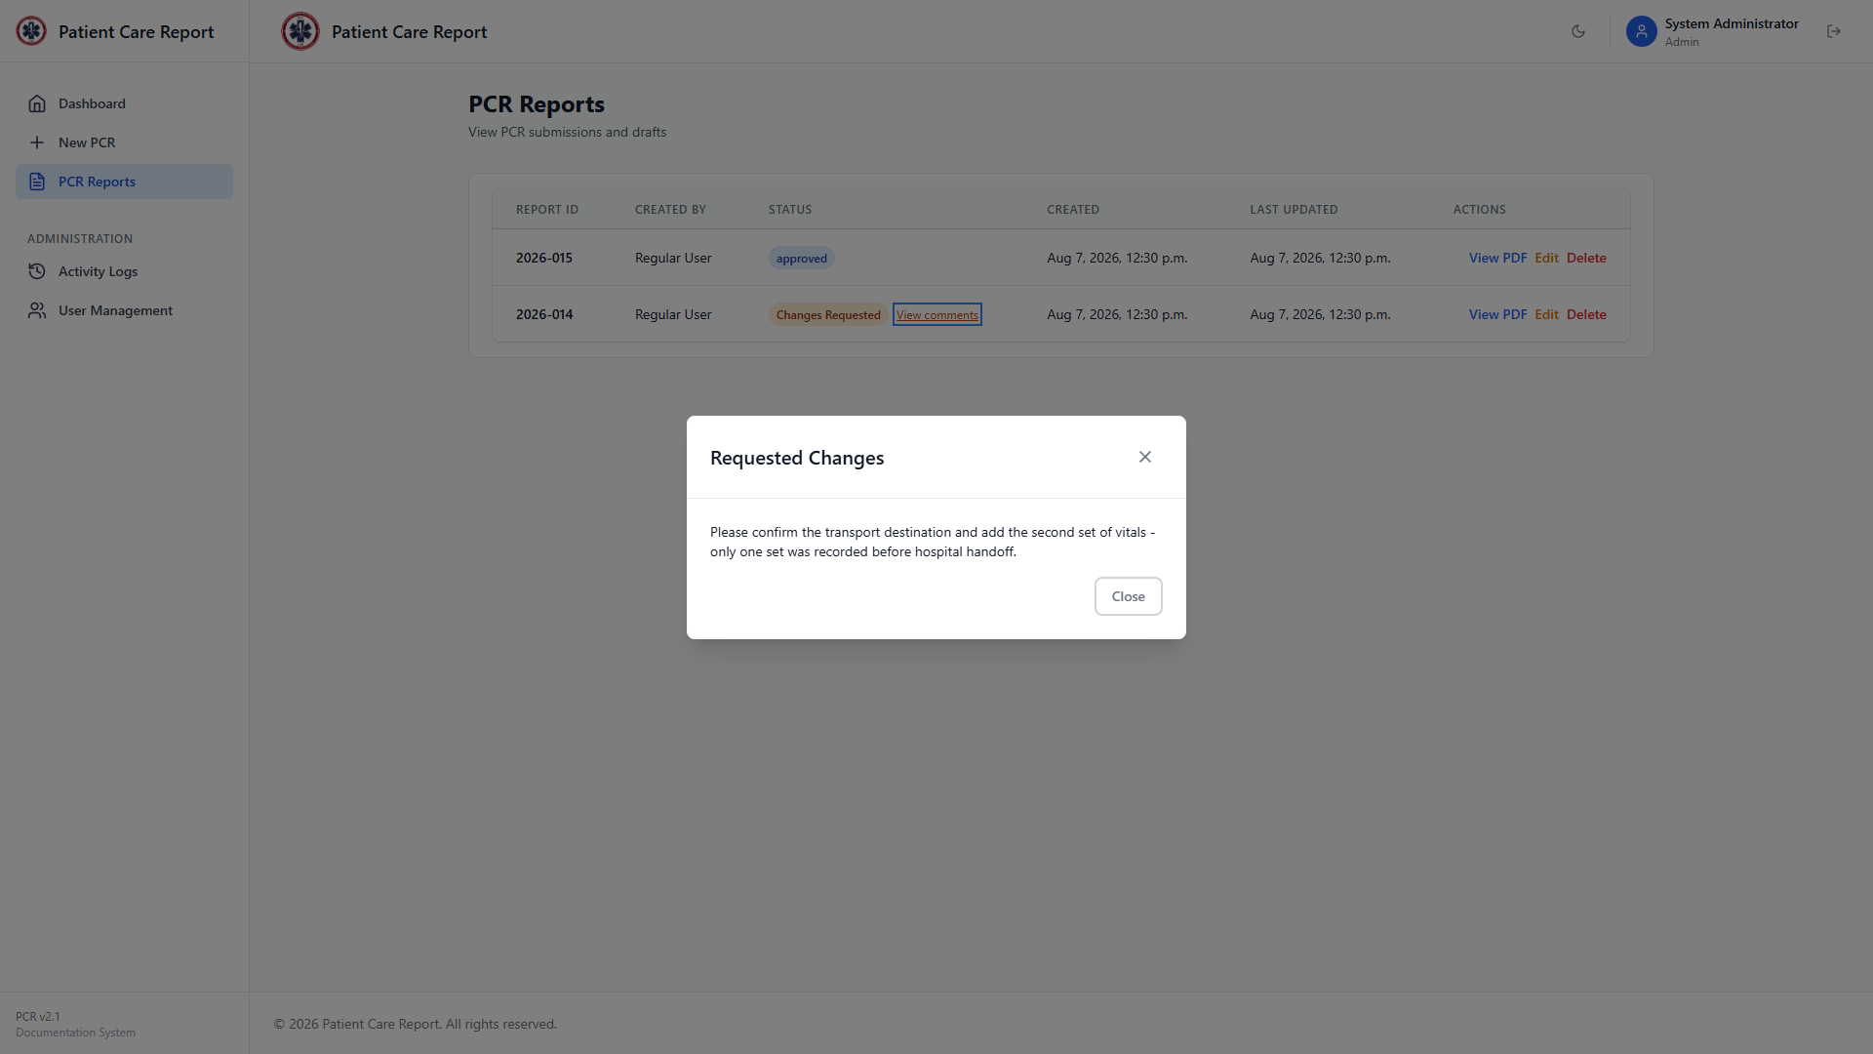
Figure 10. Reviewing the comments attached to a report sent back for changes.
From here, the submitter can edit the report and resubmit it — see the User Guide, Section 12, for what that looks like on their end. When they resubmit, the report returns to Submitted status and your comment is cleared automatically, since it's no longer pending action.
Note Request Changes is only available while a report is Submitted. Once it's Approved, this option no longer applies — edit the report directly instead if something needs fixing after approval.

9. Editing Any Report Directly
As an administrator, you can open and edit any report — submitted, changes requested, or approved — directly, without sending it back to the submitter first. Use this for small fixes you can make yourself rather than looping the submitter back in.
1. Click Edit on the report's row.
2. The full PCR form opens, pre-filled with the report's existing data. A banner at the top makes it clear you're editing an existing submitted report, not starting a new one.
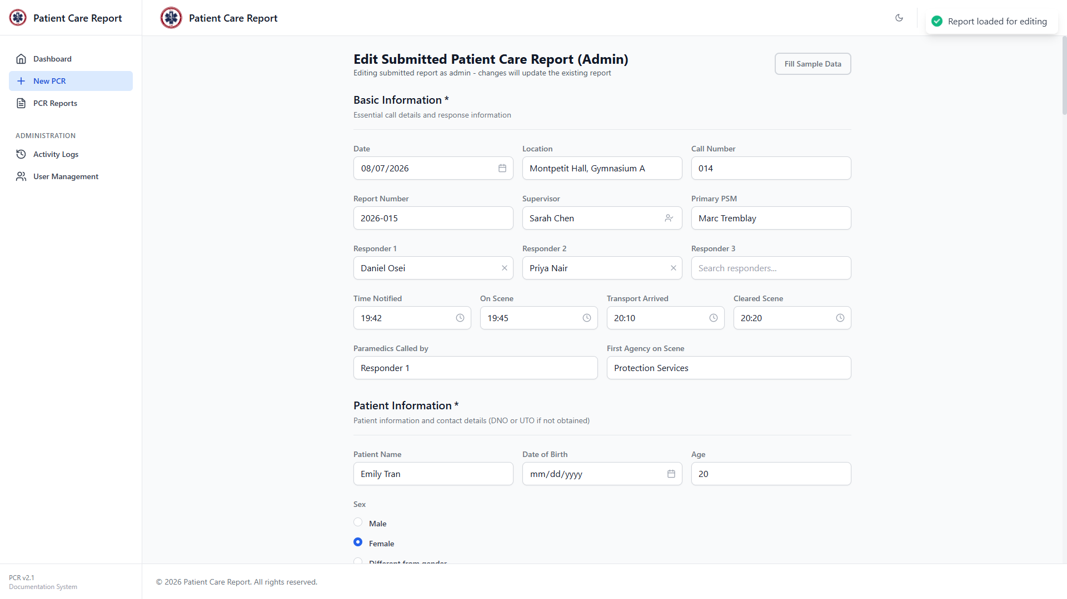
Figure 11. Editing an existing report directly as an administrator.
3. Make your changes and click Submit PCR, following the same preview-then-confirm steps described in the User Guide.
Note Saving your changes this way keeps the report at Submitted status (or moves it there, clearing any pending comments) — it does not require a separate approval step. If you're editing an already-Approved report, be sure that's actually what you intend, since there's no further review after that.

10. Deleting Reports
Click Delete on any row in PCR Reports — drafts, submitted, changes requested, or approved — to remove it permanently. You'll get a confirmation popup first.
Note This is an admin-only capability once a report leaves draft status. A regular user can only delete their own drafts — once they submit a report, deleting it is up to an admin, even if it's later sent back to them as Changes Requested.
Note There is no undo. Deleting an approved report also removes it from the organization's records, so use this deliberately rather than as a substitute for Request Changes.

11. Managing Users
Click User Management in the sidebar, under Administration. This screen lists every account in the system, sorted alphabetically with administrator accounts grouped at the bottom.
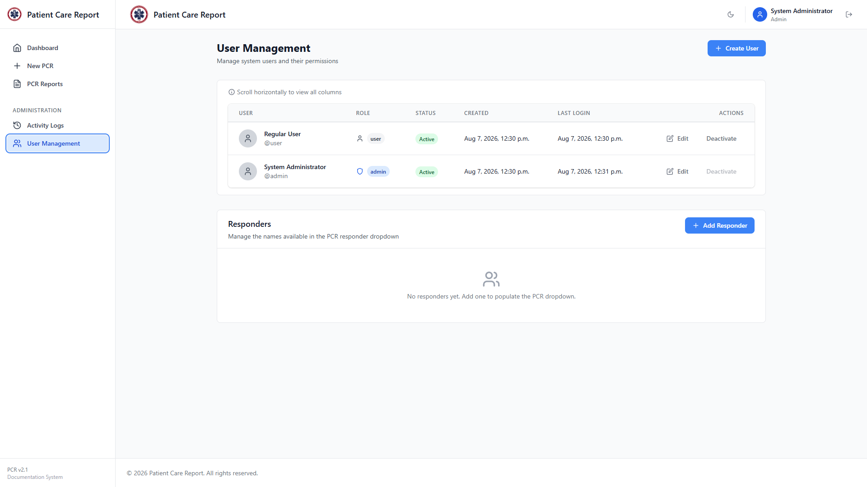
Figure 12. The User Management screen.

Creating a User
1. Click Create User in the top-right corner.
2. Fill in First Name, Last Name, Username, Password, and Confirm Password.
3. Choose a Role: User or Administrator.
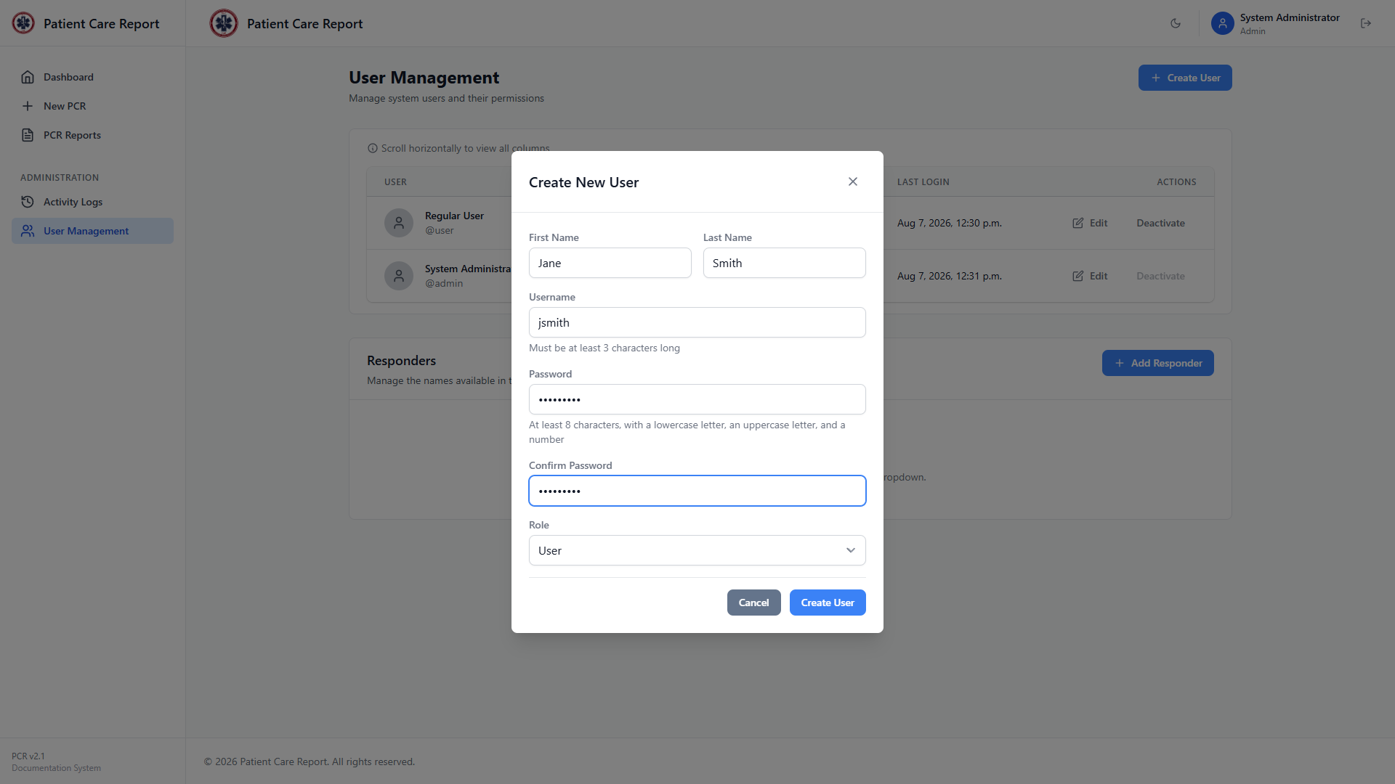
Figure 13. The Create User window, filled in.
4. Click Create User to save it. The new account appears in the list immediately and can sign in right away with the password you set.
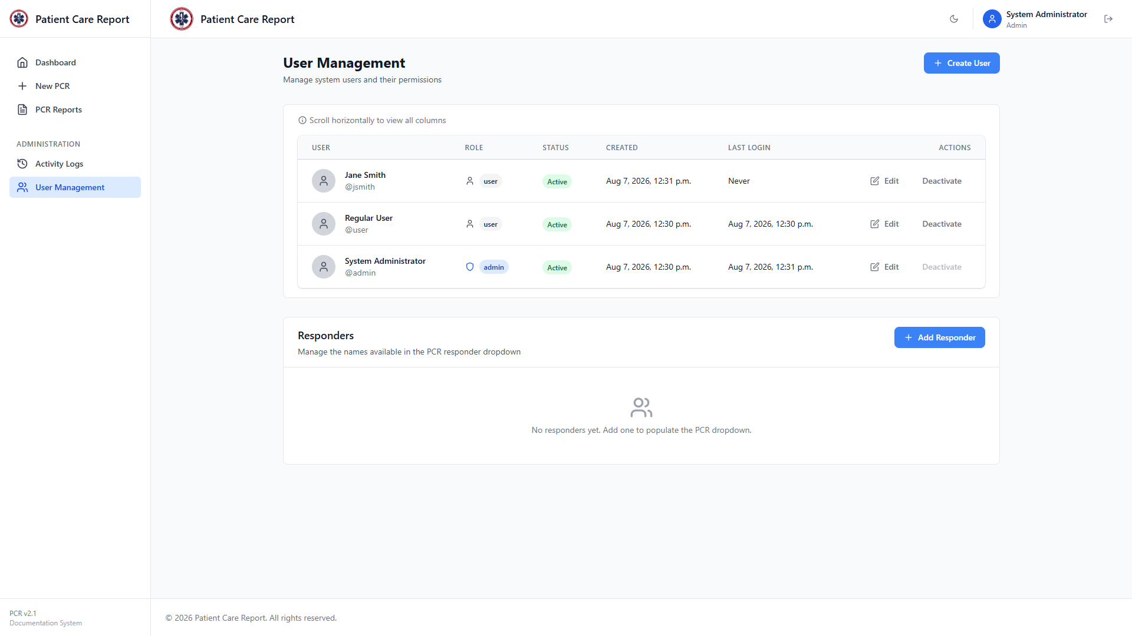
Figure 14. The user list after creating a new account.
Note Give the person their password through a separate, secure channel — it isn't emailed or shown to them automatically. They can change it themselves once account self-service is available, or you can reset it for them (see below).

Editing a User
1. Click Edit on the user's row.
2. Update First Name, Last Name, or Status (Active/Inactive) as needed. This works for administrator accounts too, with two exceptions covered in the next section: you can't deactivate yourself, and you can't deactivate the last active admin.
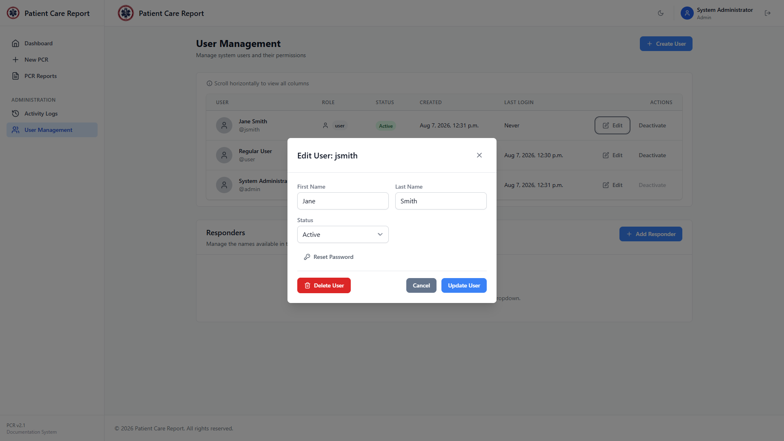
Figure 15. The Edit User window.
3. Click Update User to save, or Cancel to discard your changes.
The same window also has a Delete User button, at the bottom-left, for removing an account entirely. You'll be asked to confirm before anything happens.
Note Deletion only works for accounts that have never had a PCR report submitted under them — the system blocks it otherwise, to protect that report's history. For anyone who's actually been an active responder, use Deactivate instead (see below); Delete is really only useful for accounts created by mistake. Username and role also aren't editable from this window — if someone needs a role change, delete and recreate the account (only possible if it has no reports yet) or contact whoever maintains the system directly.

Resetting a Password
From inside the Edit User window, click Reset Password.
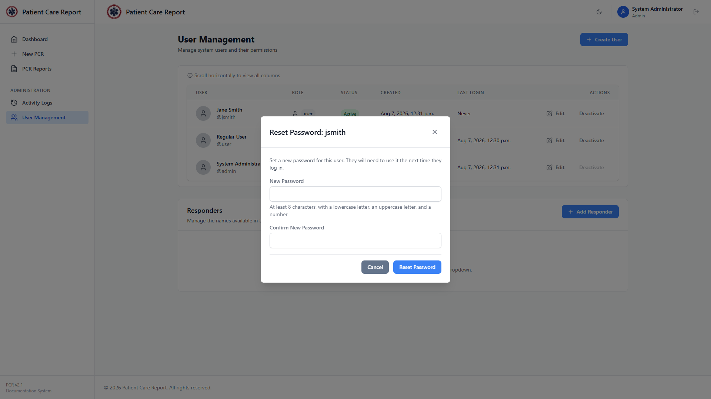
Figure 16. The Reset Password window, opened from within Edit User.
1. Enter a New Password. It needs to be at least 8 characters, with a lowercase letter, an uppercase letter, and a number.
2. Enter the same password again in Confirm New Password.
3. Click Reset Password.
Note The user will need this new password the next time they sign in. Pass it along the same way you would a newly created account's password — through a separate, secure channel, not written in the application anywhere.

Activating and Deactivating a User
Click Deactivate on a user's row to disable their account without deleting it — their reports and history stay intact, but they can no longer sign in. Click Activate on a deactivated account to restore access. This works for administrator accounts too, not just regular users — useful for a departing admin whose account can't be deleted because they've already submitted PCRs (Section 10).
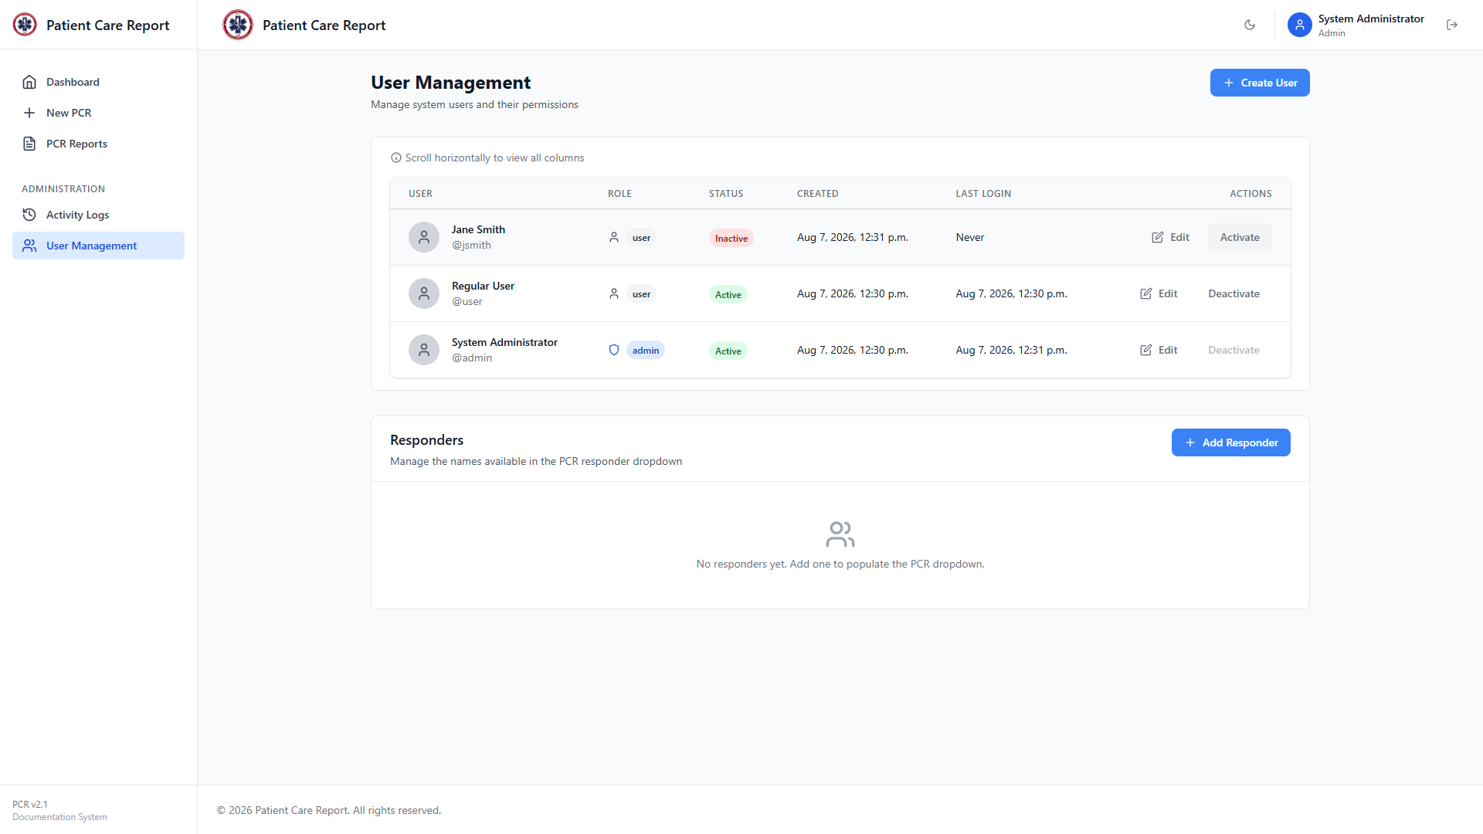
Figure 17. A user's account after clicking Deactivate — their status in the list changes to Inactive.
Note You can't deactivate your own account while you're signed in as it, and the system won't let you deactivate the last remaining active administrator — at least one has to stay able to sign in. Both the Deactivate button and the Status field inside Edit User enforce this; if a click is blocked, an error message explains which of the two rules applies.

12. Managing the Responder List
Below the user list on the User Management screen is the Responders section. This is the list of names that populate the searchable Responder 1 / 2 / 3 dropdowns on the PCR form.

Figure 18. The Responders section, at the bottom of User Management.
1. Click Add Responder.
2. Type the responder's name.
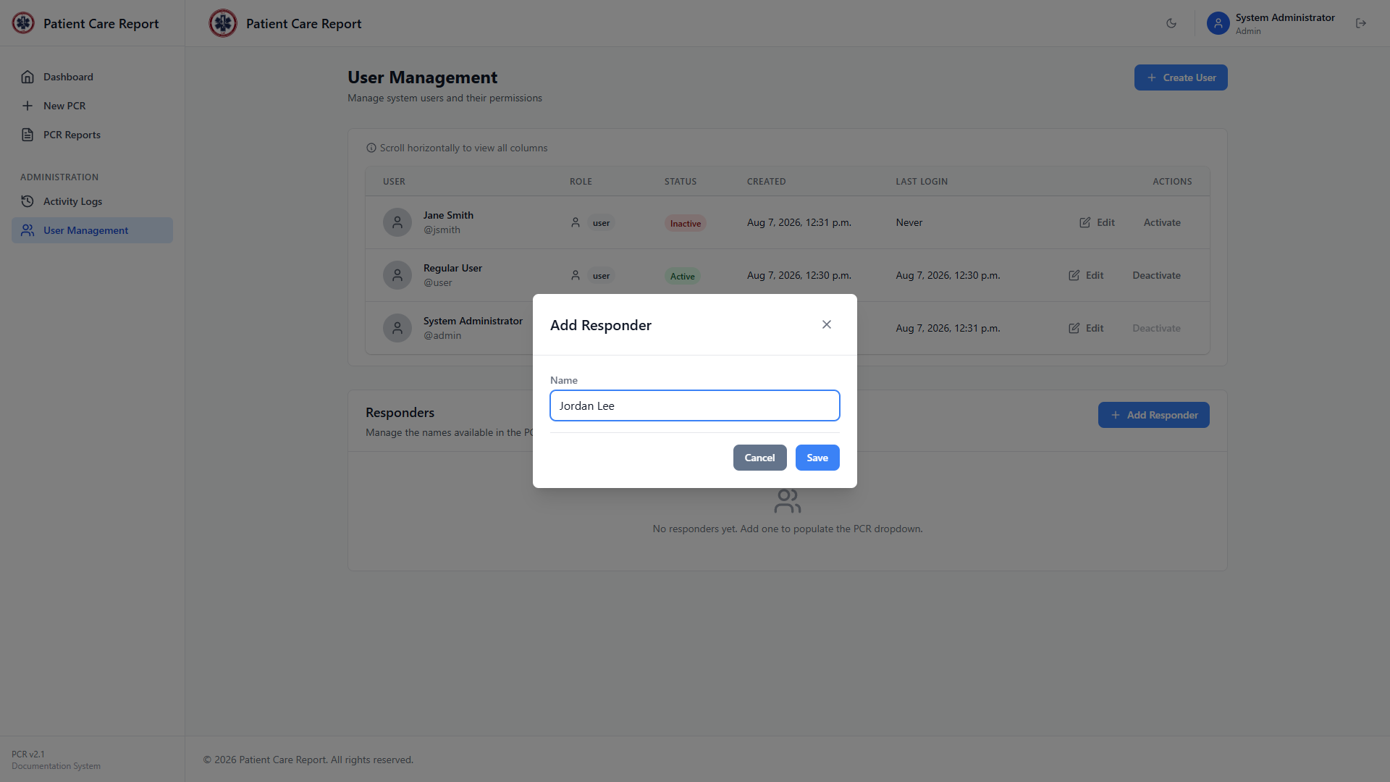
Figure 19. Adding a new responder.
3. Click Save.
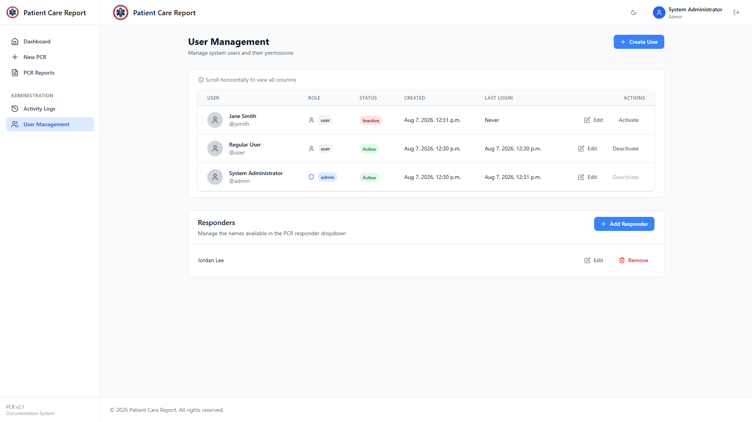
Figure 20. The responder list after adding a new name.
Click Edit next to any responder to rename them, or Remove to take them off the list. Removing a responder doesn't change any report that already used their name — it only affects what shows up as a suggestion going forward. Responders can still be typed in freeform on the PCR form even if they're not on this list.

13. Semester Setup and Roster Review
The team's roster changes every semester as members join, graduate, or step back. Two points in the year are worth a deliberate pass through the responder list and user accounts: the start of the fall semester, when the roster is largely rebuilt, and the start of winter semester, when it's worth a lighter review. Keeping both current keeps PCRs accurate and keeps sign-in access limited to people who are actually on the team.

Start of Semester

Build the responder list
The Responder 1, 2, and 3 fields on the PCR form search the responder list to suggest names as someone fills out a report (User Guide, Basic Information). Keeping that list current matters for two reasons: responders can find themselves and their teammates by name instead of typing it freehand every time, and it keeps each person's name spelled consistently across every report they appear on — which is what ties their calls together correctly in the Call Tracker statistics on the Dashboard and in Activity Logs.
Add every new responder joining the team this semester, and remove anyone who's no longer on the team (Section 12, Managing the Responder List).
Note Removing a responder from the list doesn't change any report that already used their name — it only affects what gets suggested going forward.

Create supervisor accounts
Create an account for each supervisor so they can sign in and file PCRs (Section 11, Creating a User). Choose the Role that matches what they'll actually be doing: User if they're only responding to calls and writing reports, Administrator if they'll also be reviewing and approving other responders' reports.
1. Create the account (Section 11, Creating a User).
2. Send the supervisor their username and the password you set, through a separate secure channel. The application doesn't email credentials automatically.
3. Let them know they can come to you for a password reset (Section 11, Resetting a Password) if they ever lose it.

Activate, deactivate, or delete based on roster status
Go through the user list and match each account to that person's status this semester.
- Returning members: if their account is Inactive from a previous semester, click Activate (Section 11) rather than creating a new account for them.
- Members who've left the team: click Deactivate. This blocks sign-in without touching their submitted reports or history — the safer default, and the only option once someone has ever submitted a report (see below). This applies to outgoing admins too — deactivate a departing admin's account the same way you would a regular user's.
- Accounts you're sure were created by mistake: click Delete User instead, from inside Edit User. This only works for accounts with no PCR reports attached — the system blocks deletion of anyone who's ever submitted a report, to protect that report's history — so in practice Delete is rarely the right choice for an actual former responder.
Note You can't deactivate your own account while signed in as it, and the system won't let you take the last active admin offline — one has to stay able to sign in at all times.

Winter Semester Review
Winter semester is a lighter check, not a full rebuild — most of the roster carries over from the fall.
1. Review the responder list (Section 12) for anyone who joined or left since the fall setup, and update it.
2. Review the user list (Section 11) the same way: activate anyone returning after a break, deactivate anyone who's stepped back, and delete any mistakenly-created accounts that still have no reports attached.
3. If anything looked off during the fall term — a report attributed to the wrong person, an account that shouldn't have had access — this is a natural point to check Activity Logs (Section 14) and confirm it's resolved.

14. Activity Logs
Click Activity Logs in the sidebar to see a running record of activity across the whole application: logins, PCR creation and edits, submissions, approvals, requested changes, user management changes, and more.
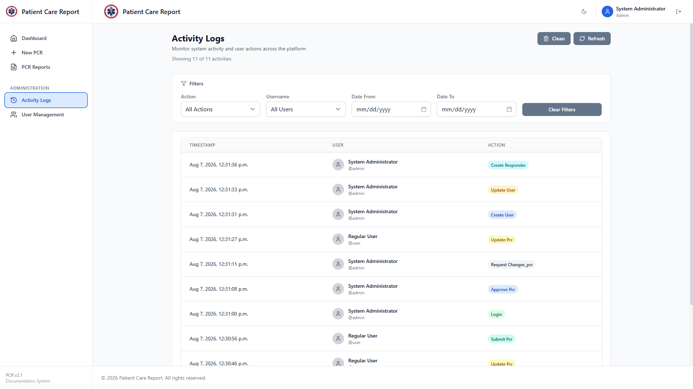
Figure 21. The Activity Logs screen.
Use the filters — Action, Username, Date From, Date To — to narrow the list down. Click Clear Filters to reset them.
- Refresh: reload the list without changing your filters.
- Clean: permanently delete old log entries past the retention period. You'll be asked to confirm before anything is deleted.
Note This log is the most reliable way to answer "who did what, and when" — for example, confirming when a specific report was approved, or by whom a user account was created.

15. Quick Reference
Common questions, answered briefly:
- Approve, or Request Changes — which should I use?: Approve when the report is accurate and complete. Request Changes when something specific needs fixing and the submitter is in the best position to fix it. Edit it yourself only for small corrections you're confident about making on their behalf.
- Can I undo an approval?: Not directly — there's no "un-approve" action. You can still edit or delete an approved report, but the submitter can't see or act on it anymore once it's approved.
- A user says their report disappeared — what happened?: It was almost certainly approved. Approved reports are removed from the submitter's own list by design (Section 4). Look it up yourself in PCR Reports, where admins retain full visibility.
- Where do I see who did what?: Activity Logs (Section 14) records essentially every meaningful action in the system, timestamped and attributed to a user.
- Can a deactivated user's old reports still be reviewed?: Yes. Deactivating an account only blocks sign-in — it doesn't touch any reports they already submitted.
- Why won't the system let me delete a former responder's account?: They've submitted at least one PCR, and deletion is blocked for any account with reports attached, to protect that report's history. Deactivate the account instead (Section 13) — that's the correct action for anyone who's actually responded to calls.
- A departing admin has already submitted PCRs — what do I do?: Deactivate their account (Section 11, Activating and Deactivating a User) — deletion will be blocked the same way it would for a regular user with report history. Deactivation works on admin accounts the same as any other, as long as it isn't the account you're currently signed in as and isn't the last active admin left.
- Why do I have to create a whole new account for a new admin?: There's no promote-to-admin action — Role is only set once, at Create User, and Edit User doesn't expose a way to change it afterward. If someone already has a regular account and now needs admin access, give them a second account with Role: Administrator rather than trying to upgrade the existing one.

